**Repo:** <https://github.com/vietphuvn/monolith-to-microservices-project>

**Application URL**: <http://af9432b9dedf64237ad41a45fb31dfe7-1824886854.us-east-1.elb.amazonaws.com>

**Github Action**:

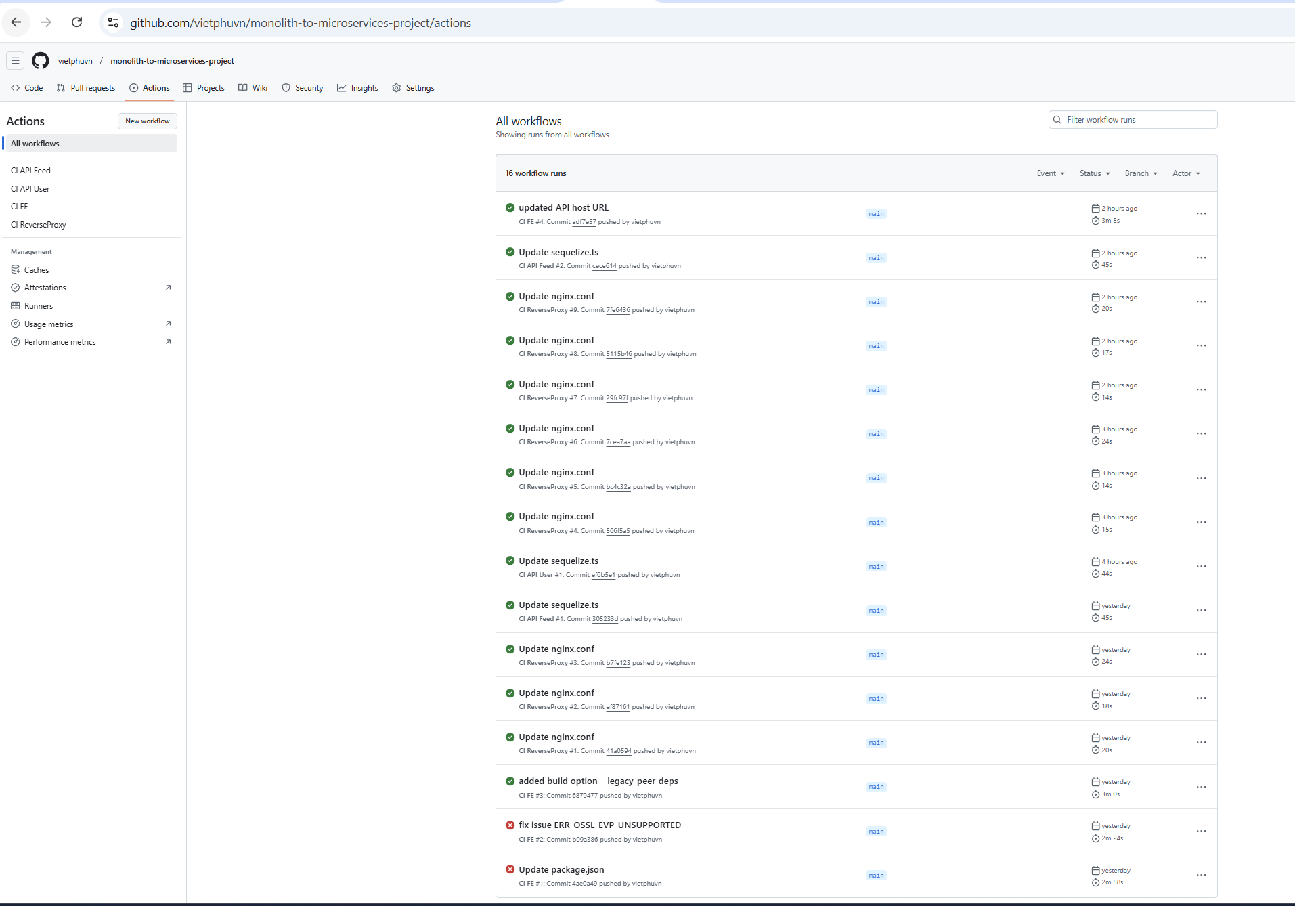

**Docker Hub**: <https://hub.docker.com/repositories/vietphuvn>

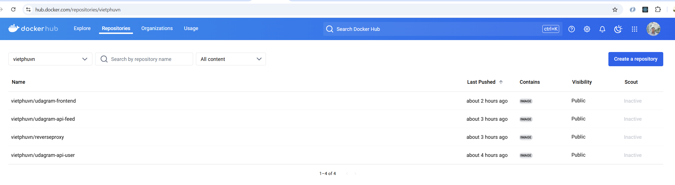

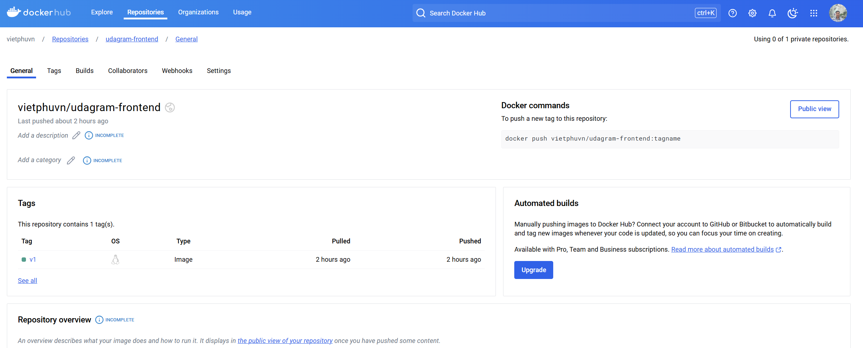

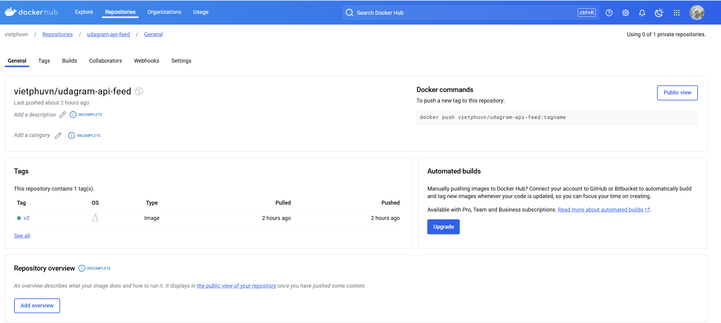

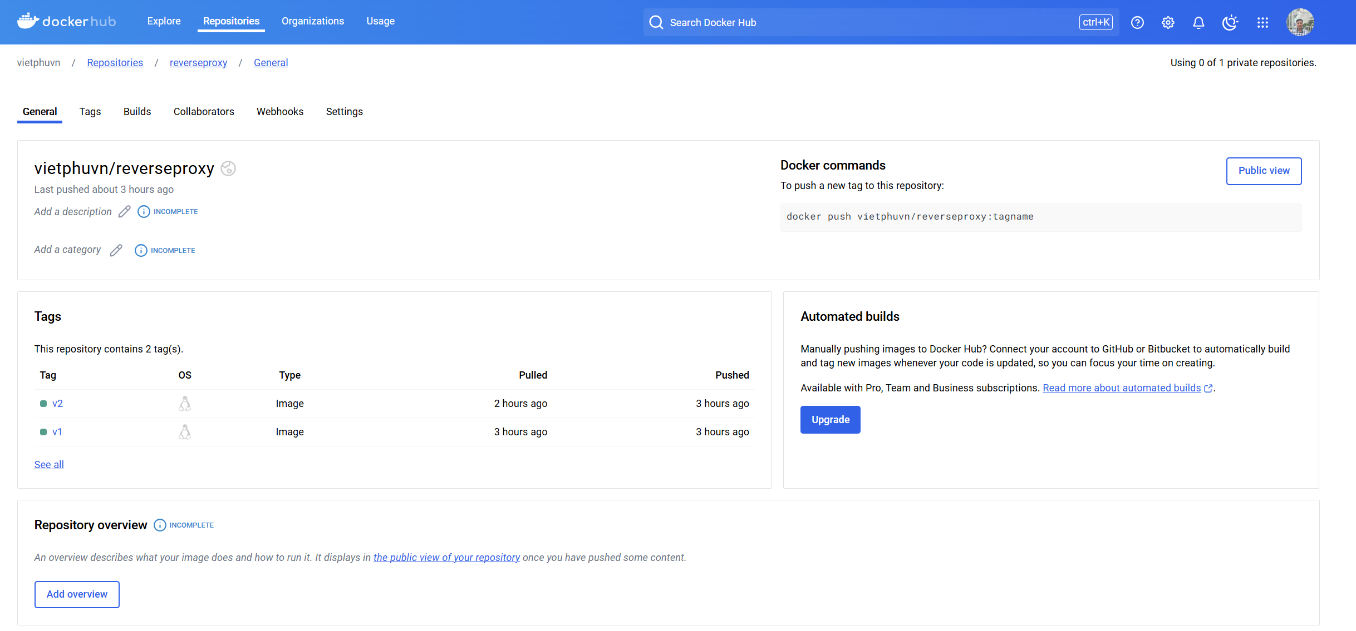

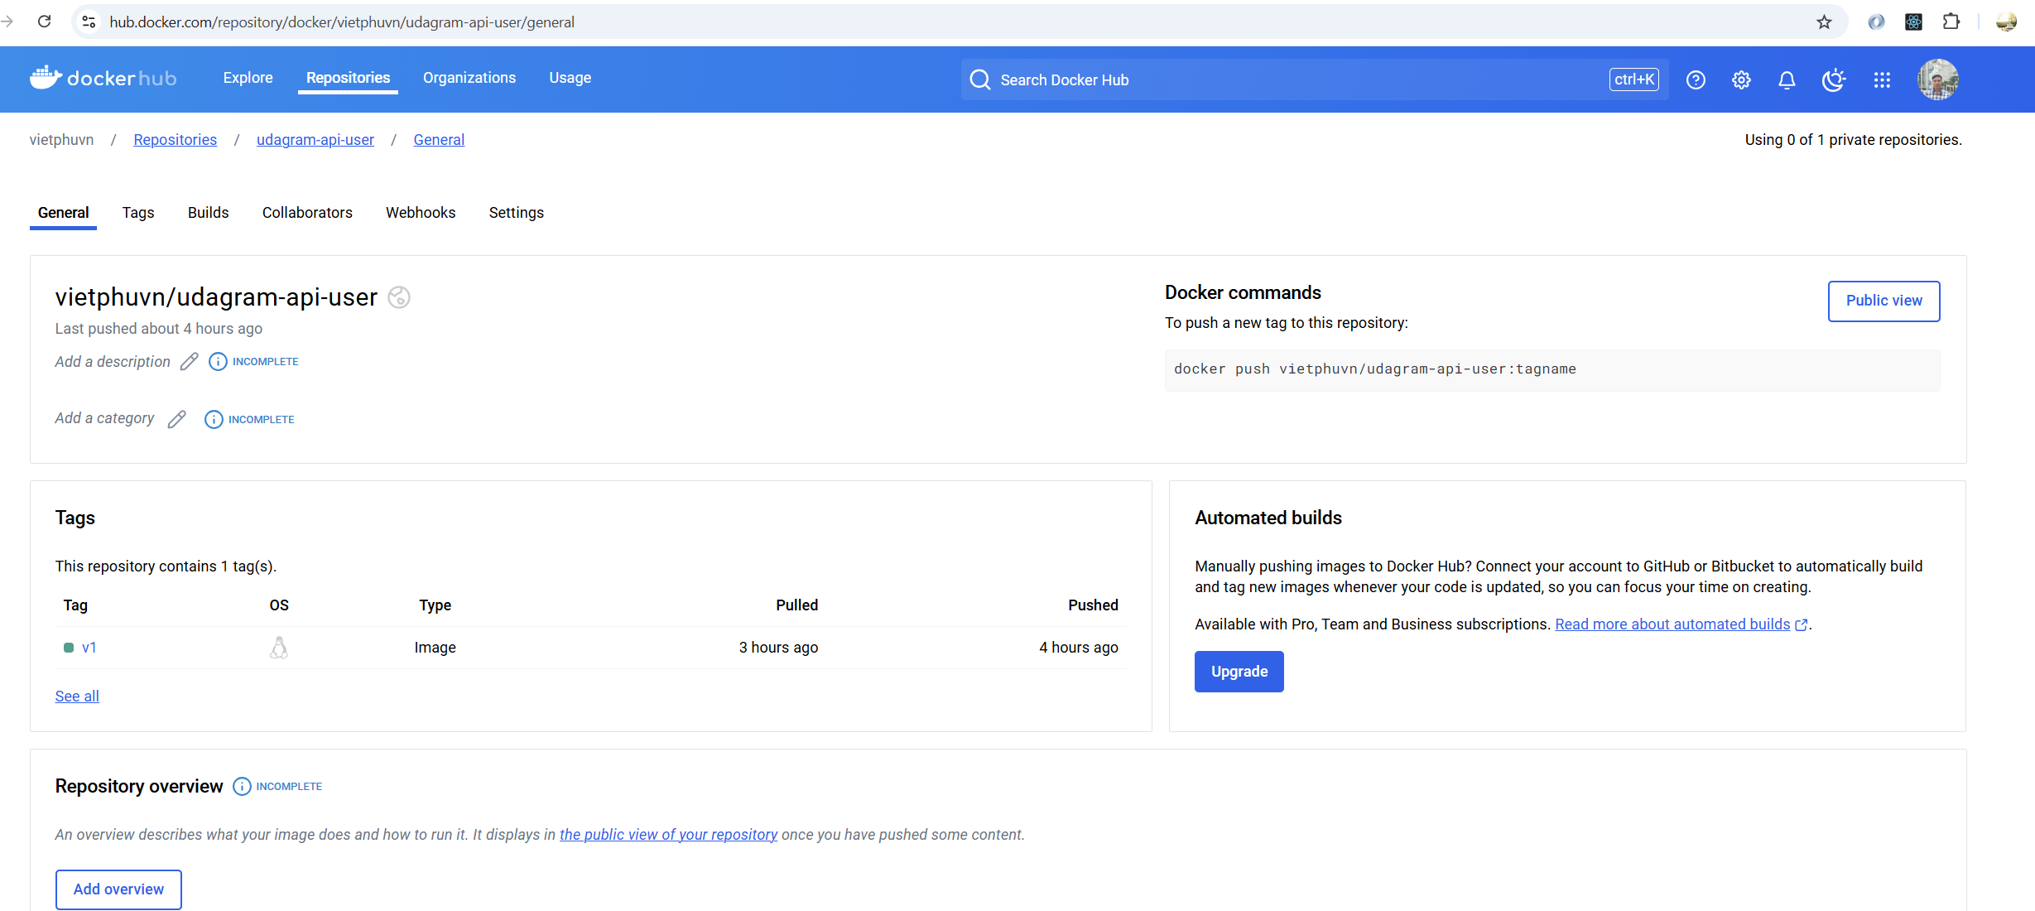

**Service Orchestration with Kubernetes**:

